|  |  |
| --- | --- |
| **Name: Evan Leglar** | **Lab Time** T 12:00 PM |

|  |
| --- |
| **Names of people you worked with:** |
| * n/a |

|  |
| --- |
| **Websites you used:** |
| <https://www.learnpyqt.com/courses/start/basic-widgets/> |

|  |  |
| --- | --- |
| **Approximately how many hours did it take you to complete this assignment (to nearest whole number)?** | 7 |

The Rules: Everything you do for this lab should be your own work. Don't look up the answers on the web, or copy them from any other source. You can look up general information about Python on the web, but no copying code you find there. Read the code, close the browser, then write your own code.

By writing or typing your name below you affirm that all of the work contained herein is your own, and was not copied or copied and altered.

Evan Leglar

**Note: Failure to sign this page will result in a 50 percent penalty. Failure to list people you worked with may result in no grade for this lab. Failure to fill out hours approximation will result in a 10-percent penalty.**

**Turn Python code to Gradescope or your assignment will not be graded**

**BEFORE YOU BEGIN**

1. Install PyQt5 using conda
2. Grab gui,py, slider.py, and random-graph.py from files
   1. Check that they all run
3. Take a look at the code, and see if you can figure out what the various pieces of it do.  For the remainder of this lab, you should build on this code, since it contains all of the boilerplate code that you'll need.

**Learning Objectives:**

You should be able to do the following:

* Create a simple GUI using PyQt5
* Know how to set callbacks
* Know how the event manager communicates with your code

**Thoughts (come back and read these after you’ve read the problems):**

1. When you create a SliderDisplay, you should be able to specify a name ('foo' in the example), low value, a high value, and an optional argument saying how many ticks (individual values) you want to slider to have.  The slider should display values to three decimal places.  As an example, if you have a low of 0, a high of 1, and 1,000 ticks, the smallest increment the slider will register is 0.001.
2. QSliders only deal with integers.  You're going to have to do some simple math to make them work with floating point numbers, like in the example.
3. Your interface doesn't have to look exactly like this.  It should have the same number of sliders, labeled in the same way, and the same buttons, but the layout and details can differ.  We're really looking for the same functionality, rather than the exact same look.
4. For the second interface, you should use your SliderDisplay class.  Make the first three sliders range from 0 to 10, time from 0 to 100, and time step from 0.001 to 0.1.  You should probably wrap up your code in a class, to help keep things encapsulated.

**Grading Checkpoints**

1. Successfully added a label. [1 point]
2. Successfully added a slider (1 point) with the correct bounds (1 point), that changes the value of the label (1 point).  [3 points]
3. SliderDisplay displays a slider and a label (1 point), in a horizontal layout (1 point), and works as expected (1 point).  [3 points]
4. Second GUI has the correct number of working sliders, using SliderDisplay (1 point), a Simulate button that works (1 point), and a quit button that works (1 point).  [3 points]
5. **Extra Credit:** Adds a graphing area to the interface (1 point), Produces Correct plot (3 points). Displays system type (1 point). [5 points]

Remember to hand in the the python files and this file (as a PDF) to Gradescope.

**Problem 1 Edit gui.py**

1. Starting with gui.py:
   1. Add a label, above the quit button, and have it initially display the value zero.
   2. Add a horizontal slider, with a range of 0 to 10, and have it change the value of the label.

|  |
| --- |
| **Comments for grader/additional information (if any)** |
|  |

|  |
| --- |
| **gui.py** |
| #!/usr/bin/env python3  from PyQt5.QtGui import *  from PyQt5.QtWidgets import QApplication, QMainWindow, QWidget, QPushButton, QVBoxLayout, QLabel, QSizePolicy, QSlider  from PyQt5.QtCore import *  import slider  class Interface(QMainWindow):  def __init__(self):  QMainWindow.__init__(self)  self.setWindowTitle('Problem 1: Slider GUI')  # A widget to hold everything  widget = QWidget()  self.setCentralWidget(widget)  # A layout  layout = QVBoxLayout()  widget.setLayout(layout)  # Problem 1 Label  self.label_slider = QLabel()  self.label_slider.setText('0')  self.label_slider.setSizePolicy(QSizePolicy.Expanding, QSizePolicy.Expanding)  self.label_slider.setAlignment(Qt.AlignCenter)  # A button  quit_button = QPushButton('Quit')  quit_button.clicked.connect(app.exit)  # Problem 1 Slider  self.slide_button = QSlider(Qt.Horizontal)  self.slide_button.setTickPosition(QSlider.TicksBelow)  self.slide_button.setMinimum(0)  self.slide_button.setMaximum(10)  self.slide_button.setTickInterval(1)  self.slide_button.valueChanged.connect(self.value)  # Widget Layouts  layout.addWidget(self.label_slider)  layout.addWidget(self.slide_button)  layout.addWidget(quit_button)  # Add other widgets to the layout here. Possibly other layouts.  def value(self):  """Return the current value of the slider"""  slider_value = self.slide_button.value()  self.label_slider.setText(str(slider_value))  if __name__ == '__main__':  app = QApplication([])  interface = Interface()  interface.show()  app.exec_() |

|  |
| --- |
| **GUI image** |
|  |

**Problem 2 Slider**

1. Edit slider.py.  This file has a class, called SliderDisplay. Edit this file to encapsulate setting the min, max, and starting values and have it include a label that displays the value.  When you're done, you should get something that looks like this:

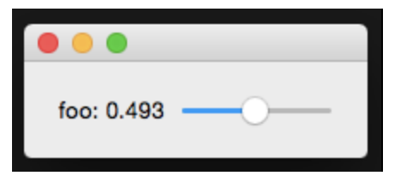

|  |
| --- |
| **Comments for grader/additional information (if any)** |
|  |

|  |
| --- |
| **slider.py** |
| #!/bin/usr/env python3  from PyQt5.QtWidgets import QApplication, QWidget, QSlider, QLabel, QHBoxLayout  from PyQt5.QtCore import *  class SliderDisplay(QWidget):  def __init__(self, name, low, high, ticks=1000):  QWidget.__init__(self)  layout = QHBoxLayout()  self.setLayout(layout)  self.ticks = ticks  # Slider  self.slider = QSlider(Qt.Horizontal)  self.slider.setMinimum(low * self.ticks)  self.slider.setMaximum(high * self.ticks)  self.slider.valueChanged.connect(self.value)  # Slider Label  self.label_slider = QLabel()  self.label_slider.setText(f'{name}:')  # Slider Value  self.slider_value = QLabel()  self.slider_value.setText('0.000')  # Widget Layouts  layout.addWidget(self.label_slider)  layout.addWidget(self.slider_value)  layout.addWidget(self.slider)  def value(self):  """Return the current value of the slider"""  slider_value = self.slider.value()/ self.ticks  self.slider_value.setText('{0: .3f}'.format(slider_value))  if __name__ == '__main__':  app = QApplication([])  slider = SliderDisplay('foo', 0, 1)  slider.show()  app.exec_() |

|  |
| --- |
| **Gui image** |
|  |

**Problem 3 lots of sliders**

1. Make a new file, gui2.py
   1. Copy gui.py into it
2. Using your slider.py code, create an interface that looks like this:

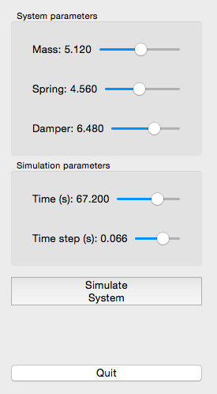

1. The Quit button should end the application, and the Simulate System button should print out the values of Mass, Spring, Damper, Time, and Time Step to the console (ie using the print function).
2. Remember, you don’t have to make it look **exactly** the same, just make sure you have the right number of sliders

|  |
| --- |
| **Comments for grader/additional information (if any)** |
|  |

|  |
| --- |
| **Gui2.py** |
| #!/usr/bin/env python3  from PyQt5.QtGui import *  from PyQt5.QtWidgets import QApplication, QMainWindow, QWidget, QPushButton, QVBoxLayout, QLabel, QSizePolicy  from PyQt5.QtCore import *  from slider import SliderDisplay  class Interface(QMainWindow):  def __init__(self):  QMainWindow.__init__(self)  self.setWindowTitle('Problem 3: Lots of Sliders')  # A widget to hold everything  widget = QWidget()  self.setCentralWidget(widget)  # A layout  layout = QVBoxLayout()  widget.setLayout(layout)  # System Parameter Sliders  self.sys_params = QLabel('System Parameters')  self.mass = SliderDisplay("Mass", 0, 10)  self.spring = SliderDisplay("Spring", 0, 10)  self.damper = SliderDisplay("Damper", 0, 10)  # Simulation Parameter Sliders  self.sim_params = QLabel('Simulation Parameters')  self.Time = SliderDisplay("Time (s)", 0, 100)  self.step = SliderDisplay("Time Step (s)", 0, 1)  # Interface buttons  simulate_button = QPushButton('Simulate System')  simulate_button.clicked.connect(self.simulate)  quit_button = QPushButton('Quit')  quit_button.clicked.connect(app.exit)  # Widget Layouts  layout.addWidget(self.sys_params)  layout.addWidget(self.mass)  layout.addWidget(self.spring)  layout.addWidget(self.damper)  layout.addWidget(self.sim_params)  layout.addWidget(self.Time)  layout.addWidget(self.step)  layout.addWidget(simulate_button)  layout.addWidget(quit_button)  def simulate(self):  print("Mass: ", self.mass.value)  print("Spring: ", self.spring.value)  print("Damper: ", self.damper.value)  print("Time: ", self.Time.value)  print("Time Step: ", self.step.value)  # def value(self):  if __name__ == '__main__':  app = QApplication([])  interface = Interface()  interface.show()  app.exec_() |

|  |
| --- |
| **Image** |
|  |

|  |
| --- |
| **Console** |
| /usr/local/bin/python3.7 /Users/evanleglar/Desktop/ME499_Python/Lab_8/gui2.py  Mass: 8.0  Spring: 4.433  Damper: 5.056  Time: 19.318  Time Step: 0.807  Process finished with exit code 0 |

**Problem 4 Extra credit**

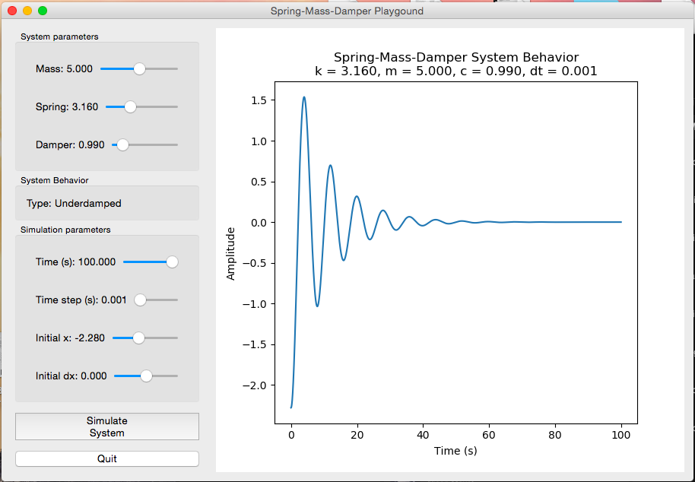

1. Add a graph of the actual system behavior to the GUI, using the spring-mass-damper simulation code from Lab 4.  When you set the parameters for the system and the simulation in the GUI, then press the "Simulate System" button, it should draw the correct graph.
   1. Values for the simulator should come from your sliders
   2. Type is calculated as sliders change
   3. Clicking Simulate system should
      1. Change the title to reflect the current values of k, m, c, and dt
      2. Change the plot appropriately.
      3. Re-calculate the type of the system and set the label appropriately
2. Hint: Look at random-graph.py

|  |
| --- |
| **Comments for grader/additional information (if any)** |
|  |

|  |
| --- |
| **Gui2.py** |
| Copy your code here |

|  |
| --- |
| **Image** |
| % Put an image of your gui with a graph here |